BIOC404 Mar. 13th, 2006
Brandon Zimmerman

So far we have seen a lot about 1D NMR involving rotations and some idea of 2D spectrums work by measuring the frequency twice. 2D involves allowing the sample to equilibrate measuring the frequency once and then move the magnetization from one nucleus to another and then measuring the frequency again.
We are only going to talk about moving the magnetization from a practical standpoint.

The advantages of 2D are two fold in that 1) we get information about the peaks that appear and 2) we are able to resolve the peaks that overlap.

There are two type of 2D NMR: 1) homonuclear, which involves only 1 atom type and 2) heteronuclear, which involves two or more atoms types.

The appearance of spectra for homonuclear 2D NMR is very different than heteronuclear because the magnetization may not move, yielding the same frequency and thus diagonal peaks. If the frequency is the same on both measurements it will give you a diagonal axis, which occurs when F1=F2. Cross peaks, which represent a shift in the magnetization, follow that F1≠F2.
Clearly, in heteronuclear NMR, diagonal peaks cannot exist because no signal will exist if the magnetization doesn’t move.

The evolution and acquisition times (t₁ and t₂) are just the period of times we measure F₁ and F₂ respectively.

3D and 4D NMR are based on the same principles as 2D NMR in that we just detect a third or fourth signal. 3D NMR is very commonly used; however, 4D NMR is not because it takes a significant amount of time to record the spectra. Each time we have to measure a frequency, the duration of the experiment increases. So whereas a 1D NMR spectrum will take 2 minutes to record, the 2D will take 30 minutes and the 3D can take around 24 hours, whereas a 4D experiment can take up to a week.

Using NMR, we want to determine the signals, which come from nuclei in the sample. The easiest way to do resonance assignment is to look at the chemical shift to whether the nucleus is in an electronegative environment or not. If the environment is electronegative this will cause a downfield shift in the signal, i.e. to a higher ppm value, whereas an upfield shift will be towards 0 or negative ppm values.
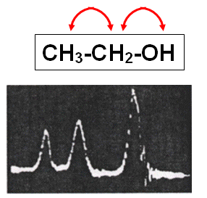
In class we used the spectrum of ethanol as an example. You can see here, 3 peaks which differ in size and chemical shift. Just doing it by proton number, we see peaks of 1H, 2H and 3H (proportionally) which allow us to distinguish the peaks for this simple spectrum. You can also differentiate between the peaks in that the hydroxyl hydrogen peak will be furthest downfield because of its bond to the oxygen, whereas the methylene peaks with be further downfield than the methyl peak due to its proximity to the hydroxyl oxygen.
A key attribute is to use the coupling between these protons to match a set of signals with the molecular structure, when we are dealing with more complex signals that ethanol.

The coupling of protons can occur in two manners, either through space or through bonds (chemical structure). The origin of these effects are very different in that the when going through bonds, it is really the effect of the electrons that is being seen, whereas this is not the case when going through space.
- The coupling through space is referred to as dipolar coupling, which utilizes the nuclear Overhauser effect (nOe). This effect is proportional to (1/r_{az})⁶ and thus can only be seen on distances under 5Å (short range), which is equivalent to approximately 5 carbon-hydrogen bonds. The effect is dependent on how the magnetization of H_{A} affects the magnetic field around H_{Z}, such that it allows the movement of the magnetization from one nucleus to another through space. The experiment we will talk about involving NOEs, is called Nuclear Overhauser Effect Spectroscopy or NOESY.
- The coupling through bonds is also referred to as scalar coupling, spin-spin coupling or J-coupling. These couplings allow us to determine, which atoms are next to each other. This may be familiar to many if not all of you from organic chemistry. As mentioned, this effect is generated by the shared electrons, involved in the bonds between the atoms. The electrons of nucleus A feel the spin of the electrons on nucleus B thus perturbing the electrons on nucleus A, which allows us to connect the atoms through the carbon backbone. This is what allows us to move magnetization from nucleus A to B, which will cause the formation of cross peaks at the frequency of A and B. The limit for J-coupling is generally 3 bond lengths, thus slightly shorter than that of NOEs. Common experiments used here are COSY (correlation spectroscopy) and TOCSY (total correlation spectroscopy). As J-coupling can only pass through 3 bonds, COSY experiments can only measure through 3 bonds. However, TOCSY experiments are able to measure over more than 3 bonds, and thus let us look at spin systems, which involves putting multiple J-couplings together.
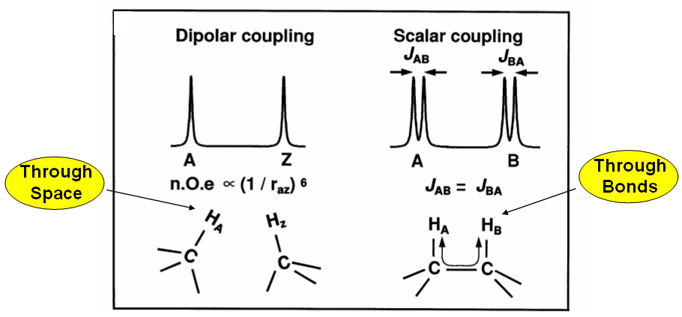
Just in case you don’t remember, vicinal (neighbour) hydrogen atoms are found on adjacent carbon atoms. Geminal (twins) carbon atoms are found on the same carbon atom.

Dr. Gehring mentioned some things that may help you remember the 3 types of experiments. The COSY experiment involves a close family and thus it is cozy. The TOCSY experiment connects this close family to its cousins, making it a larger family, and thus total correlation. Finally, the NOESY experiment involves atoms being nosey and listening/looking through space to see what other nuclei are doing.

All three experiments involve the movement of magnetization from either A to B or B to A, so if we see the movement of magnetization (i.e. a cross peak) in COSY, the magnetization moved less than 3 bonds. If the movement is seen in a TOCSY experiment, it is an extended family, generally within an amino acid. The NOESY experiment shows that they are close in space but not through bonds.

The exam problem will be a peptide of 5-9 amino acids where we will have to make the resonance assignments using the data from these experiments.

What is a spin system?
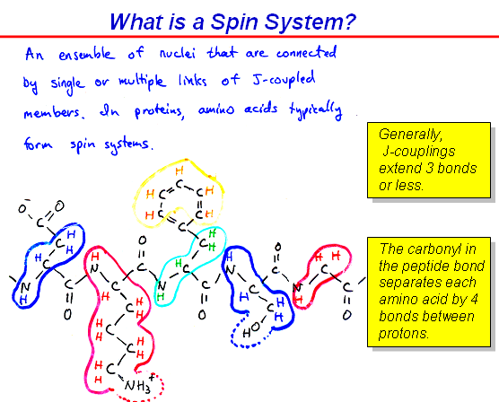
So here we have aspartic acid residue (blue one on left). The distance between the H^{N} (amide) and the H^{α} are separated by three bonds, so we would expect to see them using a COSY experiment. The H^{ß} is too far away from the amide hydrogen (4 bonds), and therefore would not be seen using a COSY. However, if we were to do a TOCSY experiment, then we would see a cross peak between each adjacent hydrogen atom, which would eventually lead us to the H^{ß}. Cross peaks between amino acid residues can only be seen in NOESY experiments when using homonuclear NMR because the carbonyl carbon does not have a hydrogen atom for the TOCSY experiment to use as a relay to cross over it (for COSY experiments it is 4 bonds between the amide hydrogen and the next amide hydrogen). In order for the TOCSY experiment to continue it requires that each link between contain something that causes J-coupling. Even when there are hydrogen atoms on each link, over longer distances the cross peaks in TOCSY experiments begin to weaken, as is the case with arginine.

J-coupling
It comes when two protons feel each others magnetic field because they share electrons and thus the coupling is through bonds (1, 2 or 3 bonds). Since the magnetic field of one hydrogen atom depends on the spin state of the adjacent hydrogen, we get a splitting of the signal. When a signal is split into two this is called a doublet.

Splitting is the same between the nuclei given in hertz because it is independent of the strength of the external magnetic field (Bº). Usually on the order of around 10hz for protons. We will not talk about strong coupling in this course, which occurs when the two hydrogen atoms get very close to each other.
When you have multiple coupling that are all the same like in the amino acid, alanine, a more complicated pattern is obtained, where the H^{α}, which is neighboured by 3H^{ß}, will give the appearance of a quartet, whereas the 3H^{ß} will only show a doublet due to the single neighbouring H^{α}. As a general rule you take the number of hydrogen atoms on the carbon you are looking at as one plus all the neighbouring hydrogen atoms. So for instance in diethyl ether, where we have CH₃CH₂OCH₂CH₃, we would expect to see the methyl protons as a triplet (1+2), whereas the methylene protons would be seen as a quartet (1+3). For the relative intensities of the peaks within doublets, triplets, etc. it follows Pascal’s triangle, when the frequency of the couplings are the same. If the couplings are different, you may see a doublet of doublets, like the 4 bond coupling seen on the substituted benzene ring but this we will also not discuss further.

Protons that are capable of exchange, i.e. amine or hydroxyl protons, may affect splitting dependent on whether the sample is in D₂O or H₂O, however, we will not discuss this.

These splittings (multiplets) are not normally seen in proteins because there are so many signals and couplings that the signals get really broad.

Homonuclear couplings can go up to about 20hz between protons for geminal protons, through three bonds coupling is generally 5-10hz. The long range couplings that we are disregarding are generally between 0 and 3hz.
Now for heteronuclear couplings, these values are much larger because you only have to pass through a single bond to go from the hydrogen to the carbon or nitrogen. The values can be seen on the slides.

For today we are going to focus on the homonuclear interactions because we are going to figure out how to assign unlabeled proteins using COSY, TOCSY and NOESY experiments. We are going to using COSY and TOCSY to identify the family or spin system, and then use the NOESY to determine the order of the spin system (exam question). This can take anywhere from a few hours to several months.
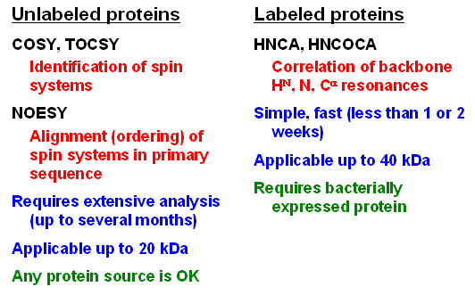
The advantage of using unlabeled proteins is that any protein source is usable, unlike for labeled proteins where we require a recombinant source that is made in bacteria.
The experiments used for labeled proteins are named by the atom, as can be seen by HNCA, which involves the amide hydrogen, the amide nitrogen and the alpha carbon and correlates them to assign the backbone. Labeled proteins are much easier to assign compared to unlabeled proteins.

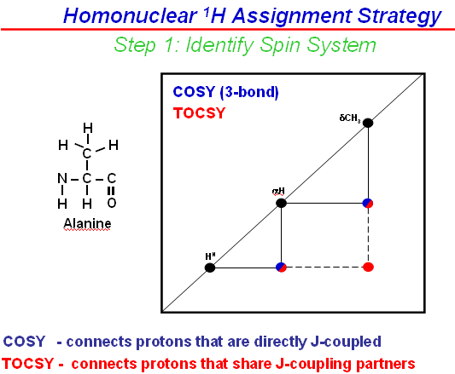
Today, we are still going to focus on a homonuclear experiment. First, we will identify our spin system by amino acids and then in a second step use the NOESY experiment to order the amino acids as best as possible into the sequence.

Some amino acids like alanine and glycine have very particular spin systems, which makes them easier to be identified. For instance, alanine is the only amino acid with a methyl group attached to its alpha carbon (i.e. next to its H^{α}). So some characteristic shifts we are required to know such as the methyl group from alanine (and most methyl groups in amino acids) is found around 1ppm. The H^{α} is in the range of 4ppm and the H^{N} is in the range of 8ppm. Then using a COSY experiment, we can establish the links between the hydrogen atoms on the alanine. The COSY experiment will only show the peaks between H^{N} and H^{α}, and H^{α} and the methyl hydrogen atoms. The appearance of a cross peak between a H^{α} and methyl protons signifies an alanine residue! The third cross peak seen in the figure corresponds to that between the amide hydrogen and the methyl hydrogen atoms and this can only be seen in the TOCSY experiment.
Another amino acid that gives a nice spectrum is leucine because of the two methyl groups. The COSY will once again give us the stepwise connections and the TOCSY will bring them all together. If you see two methyl groups connected to an amide, this narrows it down to three amino acids (Ile, Val, Leu) and then by looking at the steps from the COSY, we can determine which of the three amino acids it is.

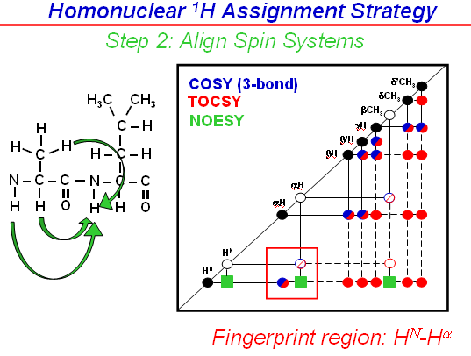
Now if we look at a dipeptide, like Ala-Leu, we have the “open circles” corresponding to the alanine and the leucine pattern filled in, once we have the COSY/TOCSY, we can use a NOESY to align them. (much more useful in color) With the NOESY, we will see the connections through space. The most important region here is the fingerprint region, which corresponds to the H^{N}-H^{α} interaction. It is much easier to interpret the spectrum here. You can do the cross peaks from A to B or B to A but only A to B is shown here in the figure. The connection in the figure here corresponds to the H^{N} of the leucine, interacting with the H^{α} of the alanine. Using the NOESY, we are able to circumvent the carbonyl group, which had been blocking our connection.
You need to be able to recognize, which peaks correspond to which arrow. There are green arrows in reality between all the adjacent hydrogen atoms less than 5Å apart in space, but for simplicity they were omitted from the diagram. When we actually do the experiment, we would overlap the TOCSY onto the NOESY, so that wherever we saw the TOCSY color, it would mean that the interaction was through space and bonds, whereas if it was NOESY color, it would only be through space.
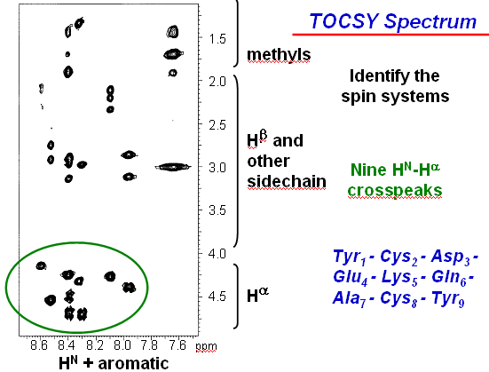
The rest of the class dealt with an example of these experiments, pertaining to a 9 residue peptide. The COSY will have 9 cross peaks from the H^{α} at around 4-5ppm and H^{N} at around 8ppm. There is no proline in the peptide, which can be seen by the presence of 9 cross peaks for 9 amino acids. Proline does not have a cross peak because it does not have an amide hydrogen. Since they show up in the TOCSY experiment, the cross peaks must be localized to the same amino acid. We can see in the figure there is 1 signal that does not have a H^{α} (far right), which is actually from a lysine side chain.

Now looking at the spectrum, we see one cross peak at a H^{N} frequency of 8ppm, and a H^{α} frequency of 4.4ppm, as well as two other protons between 2.75 and 3.25ppm, which is all 1 amino acid. Another amino acid at H^{N} frequency of 8.6ppm, and a H^{α} frequency of 4ppm, and some weak signals up around 2ppm (far left). There is one amino acid (alanine) which is easy to distinguish. This is because it will have a peak in the methyl region and no other peaks except for the H^{N}-H^{α} cross peak. It is hard to see by eye, but the peak below the single methyl group is actually not in line with it and belongs to a cross peak just adjacent to it (use a ruler). Therefore, we identified the alanine, as having a H^{N} frequency of ~8.35ppm, and a H^{α} frequency of 4.3ppm. Now we have a starting place to continue the assignments.
First, we will go back and look at just the H^{N} and H^{α}. So we have the TOCSY will 9 cross peaks each corresponding to an amino acid. Then, we overlay the NOESY (in red), where the red peaks signify interactions between amino acids. The same peak is seen in both the NOESY and the TOCSY if the interaction is close through space and bonds like the H^{N}-H^{α} interaction (which can be seen by the overlay of black and red dots in the figure).
Now we are going to connect the residues together to figure out the order. So we will try ordering the amino acids, using the identified alanine as a starting point. The alanine corresponds to peak 7, which is found at a H^{N} frequency of ~8.35ppm, and a ^{Hα} frequency of 4.3ppm. Now in the case “column” as the alanine cross peak (black), there is a red peak, which corresponds to the interaction between the amide hydrogen of alanine and the alpha hydrogen of the previous residue. This gives us a H^{α} of ~4.25ppm, which lines up with peak #6, which is a glutamine residue. This technique becomes pretty weak in large proteins because we only know the residue is nearby because folding can bring residues far away in the sequence, very close in space. However, since the amino acid in front of it is almost always nearby it is still usually a useful technique.
So now we want to find the residue before the glutamine, using the H^{N} of the glutamine (peak 6), which is found at 8.1ppm (only black peak which lines up with red peak from peak #7- use a ruler). Now, which amino acid comes before the glutamine? Here we run into a little problem due to the presence of two red peaks, one just creeping out from beneath the TOCSY peak and another just above at ~4.15ppm. So we either have to make a guess or the system stops and we need to find another place to start from. Another starting point can be looking at the terminus of the protein or peptide because the H^{α} of the last amino acid only has its own amide to interact with! Therefore, there is no NOESY peak from this H^{α}. So we need to look for a peak that only has a black peak, without a corresponding red peak along the horizontal. So peak 9, with its H^{α} at ~4.4ppm, we can see in the figure that there are no other peaks with a red peak at this chemical shift.
The second red peak seen for peak 6 is a mid range signal that originates from the H^{α} of peak 4, which is why it appears weaker than the other signals.
More on this next class.

